Diner Dash Delights Game Rules
By playing our games, you agree that you do not find them offensive, unfair or indecent.
How to Play Slots:
- Choose the amount you would like to bet with. Control the bet amount by clicking the arrows next to the Coin Value or choose Max Bet (Max Coin Value).
- Your winnings are automatically added to your account balance. You can see your Total Win displayed in the WIN section of the screen after each spin.
Game Rules:
- 8 or more matching symbols anywhere on the screen trigger a winning combination.
- Payouts are made according to the paytable.
- Wins are multiplied by Coin Value and each game costs a minimum of 20 fixed coins.
- Only the highest win in the winning combination is paid.
- Malfunction voids all pays and plays.
- For this game, the long term expected payback is 93.72%.

Gravalanche:
- A winning combination triggers Gravalanche.
- The win amount is paid, and all winning symbols explode and disappear. Symbols that are left drop down to replace exploded symbols, and new symbols drop down to fill the reel.
- Gravalanche continues until there are no more wins.

Free Spin Delights:
- 4 or more Bonus symbols appearing anywhere on the base game screen award 10 Free Spins.
- 5 additional Free Spins can be triggered if 3 or more Bonus symbols land.
- A jukebox symbol can appear on the reels only during the Free Spins. When it lands, it stays on the screen until the end of the Gravalanche.
- Whenever a jukebox symbol lands on the screen, it awards a random multiplier value of x2, x3, x4, x5, x6, x8, x10, x15, x20, x25, x50 or x100.
- When the Gravalanche ends, all the multipliers that exist on the screen are added together and the total win of the Gravalanche is multiplied by the final value.

Buy Bonus Feature:
- Buy Bonus feature is available only in the base game.
- Buy Bonus feature is played at 80xTotal Cash Bet.
- Buy Bonus feature guarantees entry into Free Spins feature.
- The long-term expected payback is 94.45% with the Buy Bonus feature.
Game Controls:
This section lists the different buttons found in the game and describes their functions.

Buttons | Function
 | Click to open menu
 | Click to open the PAYTABLE
 | Click to open the GAME SETTINGS
 | Click to open the GAME RULES
 | Click to switch full screen/exit full screen
 | Click to switch sound on/off
 | Click to spin
 | Click to max bet on a round
 | Click to open auto-bet
 | Click the X button to return to the game
You can place restrictions on game play by following any of these options:
- Stop on any win: Auto-bet function is stopped when you get any winning combination.
- Stop on single win limit: Based on the limit value selected, the Auto-bet function is stopped when your total win in a single game reaches the selected value.
- Stop on session loss limit: Based on the limit value selected, the Auto-bet function is stopped when your total loss in the session reaches the selected value, which is derived by bet minus wins.

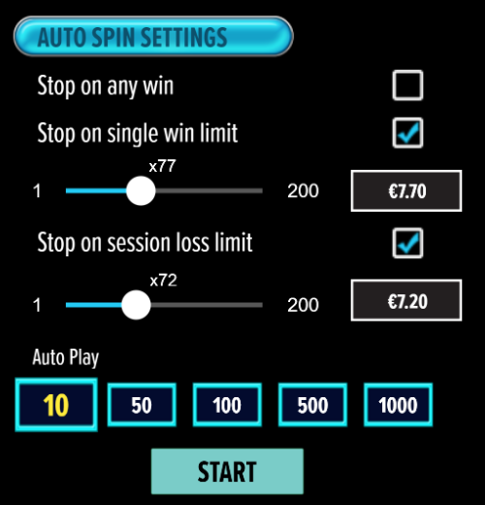

- If the game is interrupted due to connection loss during Free Spins or Bonus Rounds, the game will resume the remaining Free Spins or the pending Bonus Round upon re-opening.
Auto Spin Game Rules:
- Auto Spin is similar to a regular spin, you can choose Auto Spin for a selected number of spins.
- As soon as Auto Spin begins, the Auto Spin button is replaced by a counter displaying the remaining Auto-bet rounds. The Auto Spin button changes to the Stop Auto Spin icon.
- Auto Spin automatically plays the game for the selected number of rounds.
- Auto Spin can be stopped at any time by clicking the Auto Spin (Auto Stop) button.
- Auto Spin settings will return to default when you trigger any Feature round (Free Spins/Bonus Round).
- If you are disconnected while playing, all Auto-play settings will return to default when you reload the game.
Additional Information:
- Guidance on RTP/Bonus Feature/Wild/Free Spins is covered under the Paytable section of respective games. You can access this by clicking the Paytable button.
- Any stakes placed are non-refundable, unless a system malfunction occurs, in which case, all stakes placed on the game being played at the time of the malfunction will be refunded. We have no obligation to repay players who abuse these occurrences, and therefore, an alternative action may be deemed suitable depending on the individual circumstances.
- The in-game paytable payouts are calculated as coin value * paytable factor when bet lines are kept constant.
- If a query arises as a result of a gaming session, where there is a mismatch between your records and the data recorded by our servers, the latter will be considered correct.
- In the event of any disagreement between yourself and this website, the management's decision will be considered final.
- If the game is interrupted due to connection loss, Balance and Win information can be viewed using Game Logs.
- In the event of malfunction of gaming hardware/software, all affected game bets and payouts are rendered void and all affected bets are refunded.

