American Wonder Reels Game Rules
By playing our games, you agree that you do not find them offensive, unfair or indecent.
How to Play Slots:
- Choose the amount you would like to bet with. Control the bet amount by clicking the arrows next to the Coin Value or choose Max Bet (Max Coin Value).
- Your winnings are automatically added to your account balance. You can see your Total Win displayed in the WIN section of the screen after each spin.
Game Rules:
- The game is played with 25 fixed paylines and each game costs a minimum of 25 fixed coins.
- Payouts are made according to the paytable.
- Prizes are multiplied by the coin value.
- All symbols pay from left to right in consecutive order.
- Only the highest win is paid per selected line.
- Wild symbols substitute for all symbols, excluding the Bonus and Credit symbols.
- Malfunction voids all pays and plays.
- For this game, the long term expected payback is 93.97%.
Wonder Re-spins:
- 6 or more coin credit symbols trigger Wonder Re-spins.
- The other symbols fade away and only the coin credit symbols, that triggered the feature, remain.
- The feature starts with 3 re-spins.
- All coin credit symbols that hit after each re-spin remain on the screen until the end of the re-spins.
- Every time at least one coin credit symbol hits, the number of re-spins are reset to 3.
- This feature ends when no re-spins remain or all positions on the screen are filled with coin credit symbols.
- When this feature is complete, the values of all coin credit symbols are added and multiplied with the total bet amount.
- Player gets the Grand Jackpot along with the sum of all coin credit values when all positions on the screen are filled with coin credit symbols.
- Jackpot Rewards in this feature are:
Mini – 15x total bet
Major – 50x total bet
Grand – 500x total bet
Wonder Free Spins:
- In the base game Bonus symbols land only on reels 1, 3 and 5.
- 3 Bonus symbols landing on the reels trigger 5 Free Spins.
- During Free Spins, reels 2, 3 and 4 spin together as a colossal symbol.
- A full colossal symbol of size 3X3 will land for every Free Spin.
- All symbols can be colossal symbols including Wild, Bonus and Credits.
- 3 additional Free Spins can be re-triggered if 3 Bonus symbols land. Bonus 3X3 is 1 symbol for re-triggers.
- Wonder Re-spins can be triggered during Free Spins by landing 6 or more Credit symbols.
- If a colossal credit symbol lands on reel 2, 3 and 4, it will break into 9 different 1X1 small credit symbols and trigger Wonder Re-spins.

Buy Bonus Feature:
- Buy Bonus feature is available only in the base game.
- Buy Bonus feature is played at 85xTotal Cash Bet.
- Buy Bonus feature guarantees entry into Free Spins feature.
- The long-term expected payback is 94.15% with the Buy Bonus feature.
Game Controls:
This section lists the different buttons found in the game and describes their functions.

Buttons | Function
 | Click to open menu
 | Click to open the PAYTABLE
 | Click to open the GAME SETTINGS
 | Click to open the GAME RULES
 | Click to switch full screen/exit full screen
 | Click to switch sound on/off
 | Click to spin
 | Click to max bet on a round
 | Click to open auto-bet
 | Click the X button to return to the game
You can place restrictions on gameplay by following any of these options:
- Stop on any win: Auto-bet function is stopped when you get any winning combination.
- Stop on single win limit: Based on the limit value selected, the Auto-bet function is stopped when your total win in a single game reaches the selected value.
- Stop on session loss limit: Based on the limit value selected, the Auto-bet function is stopped when your total loss in the session reaches the selected value, which is derived by bet minus wins.

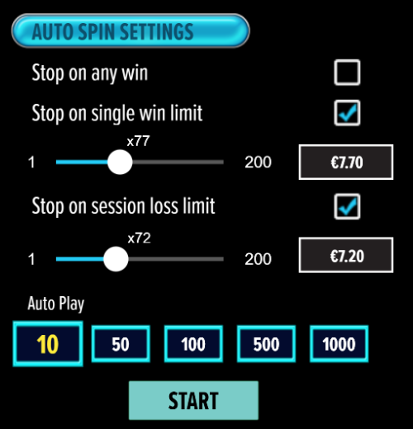

- If the game is interrupted due to connection loss during Free Spins or Bonus Rounds, the game will resume the remaining Free Spins or the pending Bonus Round upon re-opening.
Auto Spin Game Rules:
- Auto Spin is similar to a regular spin, you can choose Auto Spin for a selected number of spins.
- As soon as Auto Spin begins, the Auto Spin button is replaced by a counter displaying the remaining Auto-bet rounds. The Auto Spin button changes to the Stop Auto Spin icon.
- Auto Spin automatically plays the game for the selected number of rounds.
- Auto Spin can be stopped at any time by clicking the Auto Spin (Auto Stop) button.
- Auto Spin settings will return to default when you trigger any Feature round (Free Spin/Bonus Round).
- If you are disconnected while playing, all Auto-play settings will return to default when you reload the game.
Additional Information:
- Guidance on RTP/Paylines/Bonus Feature/Wild/Free Spins is covered under the Paytable section of respective games. You can access this by clicking the Paytable button.
- Any stakes placed are non-refundable, unless a system malfunction occurs, in which case, all stakes placed on the game being played at the time of the malfunction will be refunded. We have no obligation to repay players who abuse these occurrences, and therefore, an alternative action may be deemed suitable depending on the individual circumstances.
- The in-game paytable payouts are calculated as coin value * paytable factor when bet lines are kept constant.
- If a query arises as a result of a gaming session, where there is a mismatch between your records and the data recorded by our servers, the latter will be considered correct.
- In the event of any disagreement between yourself and this website, the management's decision will be considered final.
- If the game is interrupted due to connection loss, Balance and Win information can be viewed using Game Logs.
- In the event of malfunction of gaming hardware/software, all affected game bets and payouts are rendered void and all affected bets are refunded.

