Fishing Reels Unlocked Game Rules
By playing our games, you agree that you do not find them offensive, unfair or indecent.
How to Play Slots:
- Choose the amount you would like to bet with. Control the bet amount by clicking the arrows next to the Coin Value or choose Max Bet (Max Coin Value).
- Your winnings are automatically added to your account balance. You can see your Total Win displayed in the WIN section of the screen after each spin.
Game Rules:
- The game is played with 40 fixed paylines and each game costs a minimum of 10 fixed coins.
- Payouts are made according to the paytable.
- Prizes are multiplied by the coin value.
- All symbols pay from left to right in consecutive order.
- Only the highest win is paid per selected line.
- Malfunction voids all pays and plays.
- For this game, the long term expected payback is 94.20%.
Freddy, the Fisherman:
- Freddy can land only on reel 3 middle position.
- Freddy acts as wild.
- Freddy substitutes for all symbols, excluding the Credit, Jackpot and Bonus symbols.
- All symbols except Credit and Bonus can land on reel 3 middle position.
Unlock Feature:
- On every spin, there is a probability of triggering one or more Credit, Jackpot or Bonus symbols in a locked state.
- The condition to unlock one or more Credit, Jackpot or Bonus symbols is to land Freddy in the same spin.
- Credit Feature: When one or more Credit symbols along with Freddy land, all the Credit symbols are unlocked and summed up and then multiplied by total bet.
- Jackpot Feature: When one or more Jackpot symbols along with Freddy land, all the Jackpot symbols are unlocked and then win amount is awarded. There are 4 fixed Jackpots:
- Mini Jackpot – 5x total bet
- Minor Jackpot – 15x total bet
- Major Jackpot – 75x total bet
- Grand Jackpot – 500x total bet

Nudge Feature:
- If a non-winning combination and at least one Credit symbol land, there is a potential to award Nudge feature.
- In this feature, the reel 3 middle position rewinds and lands Freddy.

Free Spins Feature:
- When one or more Bonus symbols along with Freddy land, all the Bonus symbols are unlocked.
- Each Bonus symbol has a fixed number of spins written on it. A total of these spins is awarded as Free Spins.
- Freddy is sticky during Free Spins.
- Free Spins can be retriggered. Credit and Jackpot symbols can land during Free Spins too.

Buy Bonus Feature:
- Buy Bonus feature is available only in the base game.
- Buy Bonus feature is played at 70xTotal Cash Bet.
- Buy Bonus feature guarantees entry into Free Spins feature.
- The long-term expected payback is 94.59% with the Buy Bonus feature.
Game Controls:
This section lists the different buttons found in the game and describes their functions.

Buttons | Function
 | Click to open menu
 | Click to open the PAYTABLE
 | Click to open the GAME SETTINGS
 | Click to open the GAME RULES
 | Click to switch full screen/exit full screen
 | Click to switch sound on/off
 | Click to spin
 | Click to max bet on a round
 | Click to open auto-bet
 | Click the X button to return to the game
You can place restrictions on gameplay by following any of these options:
- Stop on any win: Auto-bet function is stopped when you get any winning combination.
- Stop on single win limit: Based on the limit value selected, the Auto-bet function is stopped when your total win in a single game reaches the selected value.
- Stop on session loss limit: Based on the limit value selected, the Auto-bet function is stopped when your total loss in the session reaches the selected value, which is derived by bet minus wins.

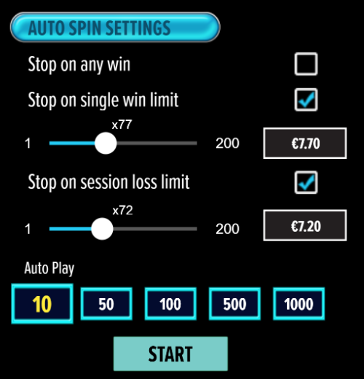

- If the game is interrupted due to connection loss during Free Spins or Bonus Rounds, the game will resume the remaining Free Spins or the pending Bonus Round upon re-opening.
Auto Spin Game Rules:
- Auto Spin is similar to a regular spin, you can choose Auto Spin for a selected number of spins.
- As soon as Auto Spin begins, the Auto Spin button is replaced by a counter displaying the remaining Auto-bet rounds. The Auto Spin button changes to the Stop Auto Spin icon.
- Auto Spin automatically plays the game for the selected number of rounds.
- Auto Spin can be stopped at any time by clicking the Auto Spin (Auto Stop) button.
- Auto Spin settings will return to default when you trigger any Feature round (Free Spin/Bonus Round).
- If you are disconnected while playing, all Auto-play settings will return to default when you reload the game.
Additional Information:
- Guidance on RTP/Paylines/Bonus Feature/Wild/Free Spins is covered under the Paytable section of respective games. You can access this by clicking the Paytable button.
- Any stakes placed are non-refundable, unless a system malfunction occurs, in which case, all stakes placed on the game being played at the time of the malfunction will be refunded. We have no obligation to repay players who abuse these occurrences, and therefore, an alternative action may be deemed suitable depending on the individual circumstances.
- The in-game paytable payouts are calculated as coin value * paytable factor when bet lines are kept constant.
- If a query arises as a result of a gaming session, where there is a mismatch between your records and the data recorded by our servers, the latter will be considered correct.
- In the event of any disagreement between yourself and this website, the management's decision will be considered final.
- If the game is interrupted due to connection loss, Balance and Win information can be viewed using Game Logs.
- In the event of malfunction of gaming hardware/software, all affected game bets and payouts are rendered void and all affected bets are refunded.

