Bison Gold Game Rules
By playing our games, you agree that you do not find them offensive, unfair or indecent.
How to Play Slots:
- Choose the amount you would like to bet with. Control the bet amount by clicking the arrows next to the Coin Value or choose Max Bet (Max Coin Value).
- Your winnings are automatically added to your account balance. You can see your Total Win displayed in the WIN section of the screen after each spin.
Game Rules:
- The game is played with 1024 ways.
- Each game costs a minimum of 50 fixed coins.
- Payouts are made according to the paytable.
- Prizes are multiplied by the coin value.
- All symbols pay from left to right in consecutive order, excluding the Bonus symbol.
- Wild symbols substitute for all symbols, excluding the Bonus symbol.
- Each symbol can be used once per winning combination.
- Only the highest win in the winning combination is paid.
- Malfunction voids all pays and plays.
- For this game, the long-term expected payback is 94.08%.

Wild Symbol:
- When Wild symbols form part of a winning combination, one of the random multipliers (x2, x3) is applied to the total win.
- In Free Spins, Wilds have a guaranteed multiplier.
- The Multiplier is multiplicative in case of multiple Wilds present on screen.
- Wild symbols are present only on reels 2, 3 and 4.

Wheel Feature:
- 3 or more Bonus symbols trigger the wheel feature.
- Wheel feature awards credits, gold bison and Free Spins.
- Players collect credits or the gold bison symbols until the wheel pointer lands on a 'Free Spins' wedge.
- Wheel feature is complete upon receiving Free Spins.

Free Spins Feature:
- Free Spins are triggered via the wheel feature only.
- 3, 4, 5 Bonus symbols trigger 8, 15 and 20 Free Spins in Base Game.
- Free Spins can be re-triggered during Free Spins.
- 2, 3, 4, 5 Bonus symbols trigger 5, 8, 15 and 20 additional Free Spins.
- As more gold bison symbols are collected, eagle, owl, rabbit and fox symbols are converted to bison symbol respective to their counters.

Game Controls:
This section lists the different buttons found in the game and describes their functions.

Buttons | Function
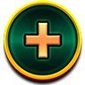 | Click to open menu
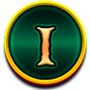 | Click to open the PAYTABLE
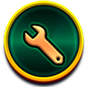 | Click to open the GAME SETTINGS
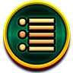 | Click to open the GAME RULES
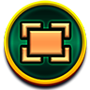 | Click to switch full screen/exit full screen
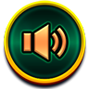 | Click to switch Sound on/off
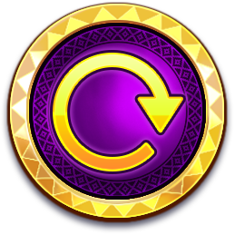 | Click to Spin
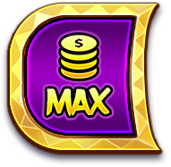 | Click to Max bet on a round
 | Click to open Auto-bet
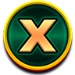 | Click the X button to return to the game
As per the U.K. Gambling Commission requirements, quick spin and auto-spin features have been disabled.
- All games are tested to level 3 standards in accordance with the UKGC Testing Strategy for Compliance with the Remote Gambling and Software Technical Standards.
- If the game is interrupted due to connection loss during Free Spins or Bonus Rounds, the game will resume the remaining Free Spins or the pending Bonus Round upon re-opening.
Additional Information:
- Guidance on RTP/ Ways/ Bonus feature/ Wild/ Free Spins is covered under the Paytable section of respective games. You can access the same by clicking on the Paytable button.
- Any stakes placed are non-refundable, unless a system malfunction occurs, in which case, all stakes placed on the game being played at the time of the malfunction will be refunded. We have no obligation to repay players who abuse these occurrences, and therefore, an alternative action may be deemed suitable depending on the individual circumstances.
- The in-game paytable payouts are calculated as coin value * paytable factor when bet lines are kept constant.
- If a query arises as a result of a gaming session, where there is a mismatch between your records and the data recorded by our servers, the latter will be considered correct.
- In the event of any disagreement between yourself and this website, the management's decision will be considered final.
- If the game is interrupted due to connection loss, Balance and Win information can be viewed using Game Logs.
- In the event of malfunction of gaming hardware/software, all affected game bets and payouts are rendered void and all affected bets are refunded.

