Mermaid’s Mega Chest Game Rules
By playing our games, you agree that you do not find them offensive, unfair or indecent.
How to Play Slots:
- Choose the amount you would like to bet with. Control the bet amount by clicking the arrows next to the Coin Value or choose Max Bet (Max Coin Value).
- Your winnings are automatically added to your account balance. You can see your Total Win displayed in the WIN section of the screen after each spin.
Game Rules:
- 5 or more matching symbols connected either vertically or horizontally is a winning combination.
- Wins are multiplied by Coin Value and each game costs a minimum of 10 fixed coins.
- Payouts are made according to the paytable.
- Only the highest win in the winning combination is paid.
- Wild symbols substitute for all symbols.
- Malfunction voids all pays and plays.
- For this game, the long term expected payback is 94.13%.
Gravalanche Feature:
- A winning combination triggers a Gravalanche.
- The win amount is paid and all winning symbols explode and disappear. Symbols that are left, drop down to replace exploded symbols and new symbols are dropped to fill the reels.
- After the new symbols are placed, a new micro-round begins for a chance of another win. A micro-round is a Gravalanche round that gives a player another opportunity to win after new symbols appear on the reels following the explosion of symbols.
- Gravalanche continues until there are no more wins.

Colossal Symbol:
- Any symbol can be a colossal symbol in both base game and free spins.
- Colossal symbol can appear at any stage in the game.

Chest Feature:
- Every winning symbol contributes towards opening the Chest.
- Up to 3 Chests can be collected during the base game and free spins.
- Chest Rewards in the base game:
- Random Wilds: 1x1 Wilds are placed anywhere on the reels. These wilds also contribute towards the Chest collection.
- Colossal Wild: One 2x2 or 3x3 Colossal Wild can be placed on the reels.
- Free Spins: 10 free spins are awarded.
- Coin Win: Coin Win is an instant reward of a monetary value.

Free Spins Feature:
- Free Spins feature is triggered via Chest feature only.
- Each Chest can award up to 3 rewards in free spins mode.
- Chest Rewards in the free game:
- Extra Free Spins: Additional free spins will be added to the existing free spins.
- Random Multiplier: A random multiplier of up to 3x can be awarded. It will not reset for the duration of free spins. Multiplier is applied to any win including the coin wins.
- Random Wilds: Same as in the base game.
- Colossal Wild: Same as in the base game.
- Coin Win: Same as in the base game.

Buy Bonus Feature:
- Buy Bonus feature is available only in the base game.
- Buy Bonus feature is played at 60xTotal Cash Bet.
- Buy Bonus feature guarantees entry into Free Spins feature.
- The long-term expected payback is 94.44% with Buy Bonus feature.
Game Controls:
This section lists the different buttons found in the game and describes their functions.

Buttons | Function
 | Click to open menu
 | Click to open the PAYTABLE
 | Click to open the GAME SETTINGS
 | Click to open the GAME RULES
 | Click to switch full screen/exit full screen
 | Click to switch sound on/off
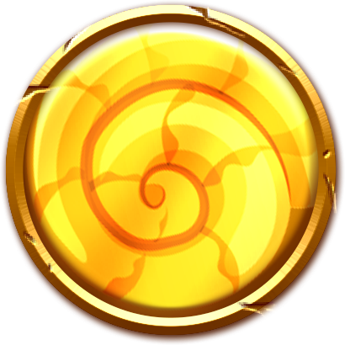 | Click to spin
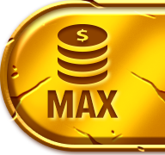 | Click to max bet on a round
 | Click to open auto-bet
 | Click the X button to return to the game
You can place restrictions on gameplay by following any of these options:
- Stop on any win: Auto-bet function is stopped when you get any winning combination.
- Stop on single win limit: Based on the limit value selected, the Auto-bet function is stopped when your total win in a single game reaches the selected value.
- Stop on session loss limit: Based on the limit value selected, the Auto-bet function is stopped when your total loss in the session reaches the selected value, which is derived by bet minus wins.

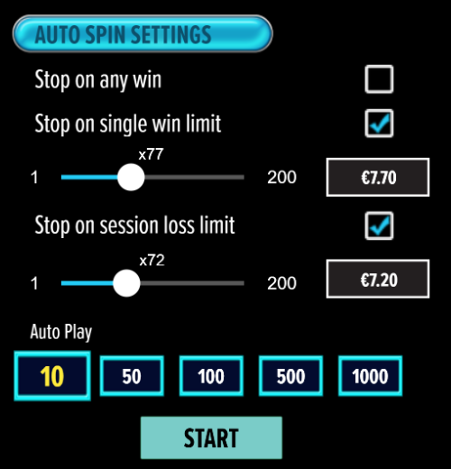

- If the game is interrupted due to connection loss during Free Spins or Bonus Rounds, the game will resume the remaining Free Spins or the pending Bonus Round upon re-opening.
Auto Spin Game Rules:
- Auto Spin is similar to a regular spin, you can choose Auto Spin for a selected number of spins.
- As soon as Auto Spin begins, the Auto Spin button is replaced by a counter displaying the remaining Auto-bet rounds. The Auto Spin button changes to the Stop Auto Spin icon.
- Auto Spin automatically plays the game for the selected number of rounds.
- Auto Spin can be stopped at any time by clicking the Auto Spin (Auto Stop) button.
- Auto Spin settings will return to default when you trigger any Feature round (Free Spin/Bonus Round).
- If you are disconnected while playing, all Auto-play settings will return to default when you reload the game.
Additional Information:
- Guidance on RTP/Paylines/Bonus Feature/Wild/Free Spins is covered under the Paytable section of respective games. You can access this by clicking the Paytable button.
- Any stakes placed are non-refundable, unless a system malfunction occurs, in which case, all stakes placed on the game being played at the time of the malfunction will be refunded. We have no obligation to repay players who abuse these occurrences, and therefore, an alternative action may be deemed suitable depending on the individual circumstances.
- The in-game paytable payouts are calculated as coin value * paytable factor when bet lines are kept constant.
- If a query arises as a result of a gaming session, where there is a mismatch between your records and the data recorded by our servers, the latter will be considered correct.
- In the event of any disagreement between yourself and this website, the management's decision will be considered final.
- If the game is interrupted due to connection loss, Balance and Win information can be viewed using Game Logs.
- In the event of malfunction of gaming hardware/software, all affected game bets and payouts are rendered void and all affected bets are refunded.

