Winfinitum Reels Game Rules
By playing our games, you agree that you do not find them offensive, unfair or indecent.
How to Play Slots:
- Choose the amount you would like to bet with. Control the bet amount by clicking the arrows next to the Coin Value or choose Max Bet (Max Coin Value).
- Your winnings are automatically added to your account balance. You can see your Total Win displayed in the WIN section of the screen after each spin.
Game Rules:
- The game is played with minimum of 10 fixed coins.
- The win is paid according to the calculations on the screen.
- Malfunction voids all pays and plays.
- For this game, the long term expected payback is 94.74%.
Base Game:
- The game is presented by a 3X1 reel set with the leftmost reel and rightmost reel containing only numbers or blank spaces*. The middle reel contains only mathematical operations “+” (Addition), “x” (Multiplication), “.” (Decimal) or blank spaces*.
- Whenever a functional (non-blank) symbol lands on all 3 reels, the mathematical calculation is applied to determine the bet multiplier. This multiplier is applied to the total cash bet to calculate the win.
- If the reels are blank*, no win is possible unless there is a feature triggered.

Nudge Feature:
- When exactly 2 reels land functional symbols, there is a potential to trigger the Nudge feature.
- During the Nudge feature, the reel that does not have a functional symbol moves in either direction.
- The Nudge feature can result in a functional symbol or a blank space*.

Ultra Spins Feature:
- When addition (+) or multiplication (x) symbols land on the middle reel, there is a potential to trigger Ultra Spins feature.
- Ultra Spins can be triggered in both winning and non-winning combinations.
- During Ultra Spins feature, leftmost and rightmost reels spin 5 times and all the potential wins are awarded to the player.

*Blank space is indicated by a hyphen towards the bottom of the reel.

Game Controls:
This section lists the different buttons found in the game and describes their functions.

Buttons | Function
 | Click to open menu
 | Click to open the PAYTABLE
 | Click to open the GAME SETTINGS
 | Click to open the GAME RULES
 | Click to switch full screen/exit full screen
 | Click to switch sound on/off
 | Click to spin
 | Click to max bet on a round
 | Click to open auto-bet
 | Click the X button to return to the game
You can place restrictions on gameplay by following any of these options:
- Stop on any win: Auto-bet function is stopped when you get any winning combination.
- Stop on single win limit: Based on the limit value selected, the Auto-bet function is stopped when your total win in a single game reaches the selected value.
- Stop on session loss limit: Based on the limit value selected, the Auto-bet function is stopped when your total loss in the session reaches the selected value, which is derived by bet minus wins.

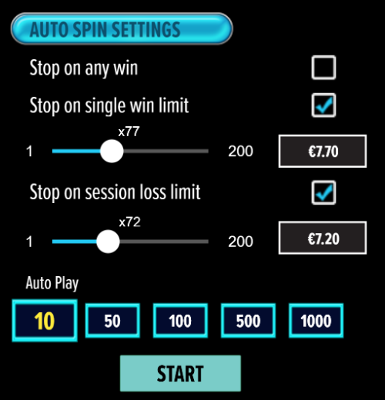

- If the game is interrupted due to connection loss during Free Spins or Bonus Rounds, the game will resume the remaining Free Spins or the pending Bonus Round upon re-opening.
Auto Spin Game Rules:
- Auto Spin is similar to a regular spin, you can choose Auto Spin for a selected number of spins.
- As soon as Auto Spin begins, the Auto Spin button is replaced by a counter displaying the remaining Auto-bet rounds. The Auto Spin button changes to the Stop Auto Spin icon.
- Auto Spin automatically plays the game for the selected number of rounds.
- Auto Spin can be stopped at any time by clicking the Auto Spin (Auto Stop) button.
- Auto Spin settings will return to default when you trigger any Feature round (Free Spin/Bonus Round).
- If you are disconnected while playing, all Auto-play settings will return to default when you reload the game.
Additional Information:
- Guidance on RTP/Paylines/Bonus Feature/Wild/Free Spins is covered under the Paytable section of respective games. You can access this by clicking the Paytable button.
- Any stakes placed are non-refundable, unless a system malfunction occurs, in which case, all stakes placed on the game being played at the time of the malfunction will be refunded. We have no obligation to repay players who abuse these occurrences, and therefore, an alternative action may be deemed suitable depending on the individual circumstances.
- If a query arises as a result of a gaming session, where there is a mismatch between your records and the data recorded by our servers, the latter will be considered correct.
- In the event of any disagreement between yourself and this website, the management's decision will be considered final.
- If the game is interrupted due to connection loss, Balance and Win information can be viewed using Game Logs.
- In the event of malfunction of gaming hardware/software, all affected game bets and payouts are rendered void and all affected bets are refunded.

