Juicy Gold 100 Game Rules
By playing our games, you agree that you do not find them offensive, unfair or indecent.
How to Play Slots:
- Choose the amount you would like to bet with. Increase or decrease the bet amount by clicking the left and right arrows and selecting an option.
- Your winnings are automatically added to your account balance. You can see your Total Win displayed on the SPIN panel of the screen after each spin.
Game Rules:
- The game is played with 20 fixed paylines and each game costs a minimum of 10 fixed coins.
- Payouts are made according to the paytable.
- Payline prizes are multiplied by the coin value.
- All symbols pay from left to right in consecutive order, excluding the Bonus symbol.
- Wild symbols substitute for all symbols, excluding the Bonus symbol.
- Bonus symbol is available on reels 2, 3 and 4.
- Only the highest win is paid per selected line.
- Malfunction voids all pays and plays.
- For this game, the long term expected payback is 94.03%.
Random Base Game Multiplier:
- A random multiplier can be awarded in the base game.
- If it is awarded, all winnings are multiplied with the random multiplier.
- Possible multipliers are x2, x5, x20 or x100.
Free Spins:
- 3 Bonus symbols award 5 Free Spins with an x2 multiplier.
- Every time 3 Bonus symbols land, a new multiplier level is awarded.
- A new multiplier level can also be achieved by collecting a certain number of Bonus symbols as illustrated below:
- While on multiplier level x2, the player needs to collect 2 Bonus symbols to reach the x5 multiplier level.
- While on multiplier level x5, the player needs to collect 5 Bonus symbols to reach the x20 multiplier level.
- While on multiplier level x20, the player needs to collect 10 Bonus symbols to reach the x100 multiplier level.
- There are no more multiplier levels to achieve post x100.
- The Free Spin counter resets to 5 with every new multiplier level achieved.
- If more Bonus symbols land than are necessary to proceed to the next multiplier level, they will not be carried over.
- A new multiplier level is applied from the following spin after the current win is evaluated.

Gamble Feature:
- Click the gamble button to activate the gamble feature.
- Selecting this feature will trigger a mini game, where you are given a choice of 2 colours.
- If the gamble selection is not made, the base game wins are added to the balance.
- You can select either the red or the blue button.
- If the card colour matches your choice, your wins are doubled.
- If there is a mismatch, all wins are lost.
- You can quit the gamble feature at any time by clicking 'Collect'.
- You can gamble up to a maximum of four times consecutively.
- The gamble feature is not available during Auto Spin or Free Spins.
Buy Bonus Feature:
- Buy Bonus feature is available only in the base game.
- Buy Bonus feature is played at 80xTotal Cash Bet.
- Buy Bonus feature guarantees entry into the Free Spins feature.
- The long-term expected payback is 94.30% with the Buy Bonus feature.
Game Controls:
This section lists the different buttons found in the game and describes their functions.

Buttons | Function
 | Click to open menu
 | Click to open the PAYTABLE
 | Click to open the GAME SETTINGS
 | Click to open the GAME RULES
 | Click to switch full screen/exit full screen
 | Click to switch sound on/off
 | Click to spin
 | Click to gamble
 | Click to open auto-bet
 | Click the arrows, pointing towards left or right, to scroll through the paytable pages
 | Click the X button to return to the game
You can place restrictions on gameplay by following any of these options:
- Stop on any win: Auto-bet function is stopped when you get any winning combination.
- Stop on single win limit: Based on the limit value selected, the Auto-bet function is stopped when your total win in a single game reaches the selected value.
- Stop on session loss limit: Based on the limit value selected, the Auto-bet function is stopped when your total loss in the session reaches the selected value, which is derived by bet minus wins.

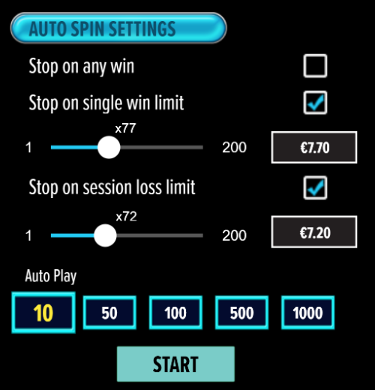

- All games are tested to level 3 standards in accordance with the UKGC Testing Strategy for Compliance with the Remote Gambling and Software Technical Standards.
- If the game is interrupted due to connection loss during Free Spins or Bonus Rounds, the game will resume the remaining Free Spins or the pending Bonus Round upon re-opening.
Auto Spin Game Rules:
- Auto Spin is similar to a regular spin, you can choose Auto Spin for a selected number of spins.
- As soon as Auto Spin begins, the Auto Spin button is replaced by a counter displaying the remaining Auto-bet rounds. The Auto Spin button changes to the Stop Auto Spin icon.
- Auto Spin automatically plays the game for the selected number of rounds.
- Auto Spin can be stopped at any time by clicking the Auto Spin (Auto Stop) button.
- Auto Spin settings will return to default when you trigger any Feature round (Free Spin/Bonus Round).
- If you are disconnected while playing, all Auto-play settings will return to default when you reload the game.
Additional Information:
- Guidance on RTP/Paylines/Bonus Feature/Wild/Free Spins is covered under the Paytable section of respective games. You can access this by clicking the Paytable button.
- Any stakes placed are non-refundable, unless a system malfunction occurs, in which case, all stakes placed on the game being played at the time of the malfunction will be refunded. We have no obligation to repay players who abuse these occurrences, and therefore, an alternative action may be deemed suitable depending on the individual circumstances.
- The in-game paytable payouts are calculated as coin value * paytable factor when bet lines are kept constant.
- If a query arises as a result of a gaming session, where there is a mismatch between your records and the data recorded by our servers, the latter will be considered correct.
- In the event of any disagreement between yourself and this website, the management's decision will be considered final.
- If the game is interrupted due to connection loss, Balance and Win information can be viewed using Game Logs.
- In the event of malfunction of gaming hardware/software, all affected game bets and payouts are rendered void and all affected bets are refunded.

