Casino Punks Game Rules
By playing our games, you agree that you do not find them offensive, unfair or indecent.
How to Play Slots:
- Choose the amount you would like to bet with. Control the bet amount by clicking the arrows next to the Coin Value or choose Max Bet (Max Coin Value).
- Your winnings are automatically added to your account balance. You can see your Total Win displayed in the WIN section of the screen after each spin.
Game Rules:
- The game is played with 5 fixed paylines and each game costs a minimum of 10 fixed coins.
- Payouts are made according to the paytable.
- Payline prizes are multiplied by coin value.
- All symbols pay from left to right in consecutive order, excluding the Bonus symbol.
- Wild symbol substitutes for all symbols, excluding the Bonus symbol.
- Only the highest win is paid per selected line.
- Malfunction voids all pays and plays.
- For this game, the long term expected payback is:
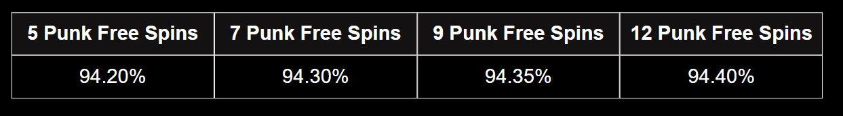

#WAGMI Multiplier:
- The #WAGMI multiplier chart shows the multiplier applicable to all wins for that spin. The multiplier increases or decreases with every spin.
- The minimum and maximum multiplier in the base game is x1 to x15.
- The multiplier changes by a maximum of +/- 5 after each spin and can never fall below x1.
- When returning to the base game after free spins, the multiplier for the first spin will be +/-5 compared to the multiplier of the last base game spin before the free spins round.
- Multiplier is applicable to payline wins only.

Gamble Punk Free Spins:
- 3 Bonus symbols anywhere on the reels award 5 Punk free spins. The player may (if they choose to do so), gamble for up to 12 Punk free spins.
- Gamble feature is represented by a wheel that is divided into green (winning) and red (losing) clusters.
- If the player wins the gamble feature, they receive additional free spins and can gamble again to receive up to 12 Punk free spins.
- The player can continue with the already won Punk free spins by clicking collect.
- If the player loses, all the Punk free spins received are lost.
- Player can gamble up to 3 times consecutively to win a maximum of 12 Free Spins.
- Gamble feature is not available if free spins are retriggered during Punk free spins.

Punk Free Spins:
- 3 Bonus symbols anywhere on the reels award 5 Punk free spins with a possibility to gamble for up to 12 Punk free spins.
- 3 Bonus symbols during Punk free spins award 5 additional Punk free spins.
- Punk free spins #WAGMI multiplier starts with x5.
- The minimum and maximum multiplier in Punk free spins is x5 to x100.
- The multiplier changes by a maximum of +40 after each free spin. During Punk free spins the multiplier either increases or remains the same. It never decreases.

Buy Bonus Feature:
- Buy Bonus feature is available only in the base game.
- Buy Bonus feature is played at 70xTotal Cash Bet.
- Buy Bonus feature guarantees entry into Punk Free Spins feature.
- The long-term expected payback with the Buy Bonus feature is:
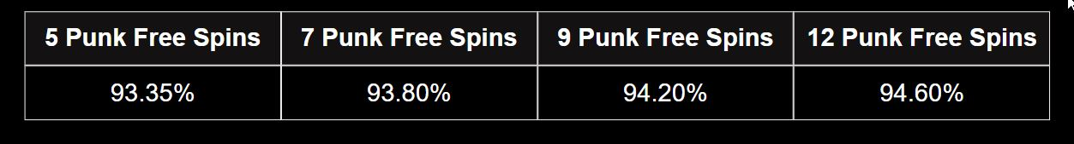
Game Controls:
This section lists the different buttons found in the game and describes their functions.

Buttons | Function
 | Click to open menu
 | Click to open the PAYTABLE
 | Click to open the GAME SETTINGS
 | Click to open the GAME RULES
 | Click to switch full screen/exit full screen
 | Click to switch sound on/off
 | Click to spin
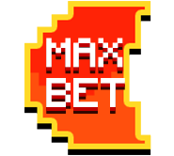 | Click to max bet on a round
 | Click to open auto-bet
 | Click the arrows, pointing towards left or right, to scroll through the paytable pages
 | Click the X button to return to the game
You can place restrictions on gameplay by following any of these options:
- Stop on any win: Auto-bet function is stopped when you get any winning combination.
- Stop on single win limit: Based on the limit value selected, the Auto-bet function is stopped when your total win in a single game reaches the selected value.
- Stop on session loss limit: Based on the limit value selected, the Auto-bet function is stopped when your total loss in the session reaches the selected value, which is derived by bet minus wins.

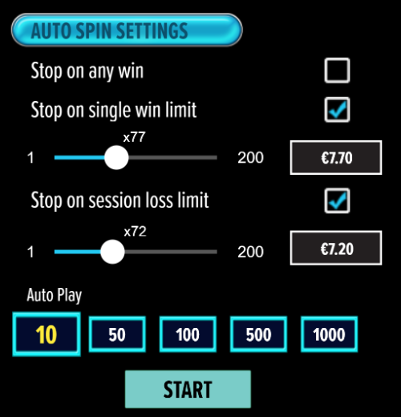

- If the game is interrupted due to connection loss during Free Spins or Bonus Rounds, the game will resume the remaining Free Spins or the pending Bonus Round upon re-opening.
Auto Spin Game Rules:
- Auto Spin is similar to a regular spin, you can choose Auto Spin for a selected number of spins.
- As soon as Auto Spin begins, the Auto Spin button is replaced by a counter displaying the remaining Auto-bet rounds. The Auto Spin button changes to the Stop Auto Spin icon.
- Auto Spin automatically plays the game for the selected number of rounds.
- Auto Spin can be stopped at any time by clicking the Auto Spin (Auto Stop) button.
- Auto Spin settings will return to default when you trigger any Feature round (Free Spin/Bonus Round).
- Auto Spin will continue after completion of Re-Spins.
- If you are disconnected while playing, all Auto-play settings will return to default when you reload the game.
Additional Information:
- Guidance on RTP/Paylines/Bonus Feature/Wild/Free Spins is covered under the Paytable section of respective games. You can access this by clicking the Paytable button.
- Any stakes placed are non-refundable, unless a system malfunction occurs, in which case, all stakes placed on the game being played at the time of the malfunction will be refunded. We have no obligation to repay players who abuse these occurrences, and therefore, an alternative action may be deemed suitable depending on the individual circumstances.
- The in-game paytable payouts are calculated as coin value * paytable factor when bet lines are kept constant.
- If a query arises as a result of a gaming session, where there is a mismatch between your records and the data recorded by our servers, the latter will be considered correct.
- In the event of any disagreement between yourself and this website, the management's decision will be considered final.
- If the game is interrupted due to connection loss, Balance and Win information can be viewed using Game Logs.
- In the event of malfunction of gaming hardware/software, all affected game bets and payouts are rendered void and all affected bets are refunded.

