Dragon Fortress - Battle of the Castle Game Rules
By playing our games, you agree that you do not find them offensive, unfair or indecent.
How to Play Slots:
- Choose the amount you would like to bet with. Control the bet amount by clicking the arrows next to the Coin Value or choose Max Bet (Max Coin Value).
- Your winnings are automatically added to your account balance. You can see your Total Win displayed in the WIN section of the screen after each spin.
Game Rules:
- The game is played with 243 ways in the main game and Free Spins.
- Each game costs a minimum of 20 fixed coins.
- Payouts are made according to the paytable.
- Prizes are multiplied by the coin value.
- All symbols pay from left to right in consecutive order, excluding the Scatter symbol.
- Wild symbols substitute for all symbols, excluding the Scatter symbol.
- Each symbol can be used once per winning combination.
- Malfunction voids all pays and plays.
- For this game, the long term expected payback is 94.09%.
Arcade:
- The arcade contains empty cells, mystery chests and secret doors that are generated randomly.
- Every time a Scatter lands on the reels, it displays a random number from 1 to 6. This number represents the total number of steps Colin the Conqueror moves forward on the arcade. If more than one Scatter lands, the numbers from each Scatter are added together and Colin the Conqueror moves that many steps.
Mystery Rewards via Secret Doors and Mystery Chests:
Every time Colin the Conqueror passes by a mystery chest or lands on a secret door, mystery rewards are awarded.
Possible Mystery Rewards:
- Cash Prize: Cash Prize is an instant reward of a monetary prize.
- Random Wilds: 1 to 3 wilds are placed randomly on the reels and then the total payline win is calculated.
- Random Wild Reels: A wild reel is placed randomly on any one of the reels and then the total payline win is calculated.
- Win Multiplier: After a multiplier is awarded, the line win, Cash Prize or other feature is multiplied by the win multiplier.
- Mini Game Wheel: The Mini Game wheel consists of the following features
- Fortune Bonus Pick: When this feature is awarded, the reels transform into 15 mystery coins. All Cash Prizes are collected until the RIP symbol is picked. This win is multiplied by the total bet and then awarded to the player.
- Hero Lottery: When this feature is awarded, the reels transform into 15 mystery coins. Each click displays an amount to be won. The player needs to get 3 of a kind in order to win the prize. Hero Lottery win is multiplied by the total bet and then awarded to the player.
- Treasure Chest Spins: When this feature is awarded, the reels disappear and the space is converted into an empty grid. The game starts with 3 spins and 3 coins with prizes. If at least 1 new coin lands on the reels, the number of spins resets to 3. The game is over when 3 consecutive spins land no new coins. The Treasure Chest Spins win is multiplied by the total bet and then awarded to the player.
- Dragon Free Spins: Dragon Free Spins are triggered with an indefinite number of spins. During Dragon Free Spins when Colin the Conqueror reaches the Boss, the Boss Fight is triggered.

Dragon Free Spins:
- Dragon Free Spins are triggered from either 3 Scatters in the main game or from the mini game wheel.
- Dragon Free Spins are triggered with an indefinite number of spins.
- Scatters do not award additional free spins during free spins.
- Like in the base game, mystery rewards can be awarded either via secret doors or mystery chests during Dragon Free Spins.
- Dragon Free Spins cannot be retriggered.
- When Colin the Conqueror reaches the Boss, the Boss Fight is triggered.

Boss Fight:
- In the Boss Fight each participant gets a bar of 10 health points. If player meets more Bosses, the health points are carried over from the previous Boss Fight.
- On clicking the ‘FIGHT’ button, a 1 to 6 value is randomly selected for each participant.
- If Colin the Conqueror's value is higher, he attacks and removes the number of health points from the Boss, otherwise the Boss attacks him and removes that number of health points from Colin the Conqueror.
- If points are equal, the player clicks on the ‘FIGHT’ button for the next draw.
- If Colin the Conqueror has no more health points, the Dragon Free Spins are over and the player collects all the winnings from Dragon Free Spins and an additional prize of 5xTotal Bet.
- If the Boss is defeated, the player receives a 50xTotal Bet and continues Free Spins once again.
Buy Mini Game:
- Buy mini game feature is available only in the base game.
- Buy mini game feature is played at 50xTotal Cash Bet.
- Buy mini game feature guarantees entry into one of the mini games, offered through the mini game wheel. Buy mini game feature does not guarantee a specific feature including Dragon Free Spins.
- The long-term expected payback is 94.48% with buy mini game feature.
Game Controls:
This section lists the different buttons found in the game and describes their functions.

Buttons | Function
 | Click to open menu
 | Click to open the PAYTABLE
 | Click to open the GAME SETTINGS
 | Click to open the GAME RULES
 | Click to switch full screen/exit full screen
 | Click to switch sound on/off
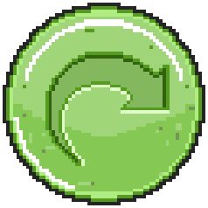 | Click to spin
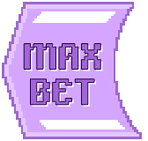 | Click to max bet on a round
 | Click to open auto-bet
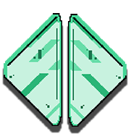 | Click the arrows, pointing towards left or right, to scroll through the paytable pages
 | Click the X button to return to the game
You can place restrictions on gameplay by following any of these options:
- Stop on any win: Auto-bet function is stopped when you get any winning combination.
- Stop on single win limit: Based on the limit value selected, the Auto-bet function is stopped when your total win in a single game reaches the selected value.
- Stop on session loss limit: Based on the limit value selected, the Auto-bet function is stopped when your total loss in the session reaches the selected value, which is derived by bet minus wins.

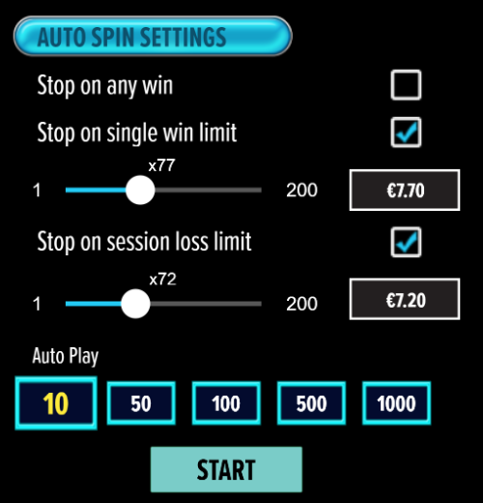

- All games are tested to level 3 standards in accordance with the UKGC Testing Strategy for Compliance with the Remote Gambling and Software Technical Standards.
- If the game is interrupted due to connection loss during Free Spins or Bonus Rounds, the game will resume the remaining Free Spins or the pending Bonus Round upon re-opening.
Auto Spin Game Rules:
- Auto Spin is similar to a regular spin, you can choose Auto Spin for a selected number of spins.
- As soon as Auto Spin begins, the Auto Spin button is replaced by a counter displaying the remaining Auto-bet rounds. The Auto Spin button changes to the Stop Auto Spin icon.
- Auto Spin automatically plays the game for the selected number of rounds.
- Auto Spin can be stopped at any time by clicking the Auto Spin (Auto Stop) button.
- Auto Spin settings will return to default when you trigger any Feature round (Free Spin/Bonus Round).
- If you are disconnected while playing, all Auto-play settings will return to default when you reload the game.
Additional Information:
- Guidance on RTP/ Ways/ Bonus feature/ Wild/ Free Spins is covered under the Paytable section of respective games. You can access the same by clicking on the Paytable button.
- Any stakes placed are non-refundable, unless a system malfunction occurs, in which case, all stakes placed on the game being played at the time of the malfunction will be refunded. We have no obligation to repay players who abuse these occurrences, and therefore, an alternative action may be deemed suitable depending on the individual circumstances.
- The in-game paytable payouts are calculated as coin value * paytable factor when bet lines are kept constant.
- If a query arises as a result of a gaming session, where there is a mismatch between your records and the data recorded by our servers, the latter will be considered correct.
- In the event of any disagreement between yourself and this website, the management's decision will be considered final.
- If the game is interrupted due to connection loss, Balance and Win information can be viewed using Game Logs.
- In the event of malfunction of gaming hardware/software, all affected game bets and payouts are rendered void and all affected bets are refunded.

