Book of Dracula Game Rules
By playing our games, you agree that you do not find them offensive, unfair or indecent.
How to Play Slots:
- Choose the amount you would like to bet with. Control the bet amount by clicking the arrows next to the Coin Value or choose Max Bet (Max Coin Value).
- Your winnings are automatically added to your account balance. You can see your Total Win displayed in the WIN section of the screen after each spin.
Game Rules:
- The game is played with 10 fixed paylines and each game costs a minimum of 10 fixed coins.
- Payouts are made according to the paytable.
- Payline prizes are multiplied by coin value.
- All symbols pay from left to right in consecutive order, excluding the Scatter symbol.
- Wild symbols substitute for all symbols and only the highest win amount will be paid.
- Only highest win is paid per selected line.
- Malfunction voids all pays and plays.
- For this game, the long-term expected payback is 95.58%.
Free Spins:
- The Scatter symbol also acts as the Wild symbol, which substitutes for all symbols, excluding the Expanding symbols during Free Spin respins.
- The Free Spins feature is triggered when 3 or more Scatter symbols land anywhere on the reels.
- 3, 4 or 5 Scatter symbols award 10 Free Spins with Expanding symbol.
- Before entering into Free Spins, one of nine symbols excluding the Scatter symbol is selected as the Expanding symbol and remains throughout Free Spins.
- 3 or more Scatter symbols during Free Spins award an additional 10 Free Spins with the same Expanding symbols in play.
Bonus Reel Respin Feature in Free Spins:
- In Free Spins there is an additional 6th Bonus reel available. This reel contains Expanding symbols and blank spaces only.
- Bonus Reel Respins in Free Spins will be triggered if there are minimum of 1 and maximum 4 Expanding symbols triggered on reels.
- When all the Free Spin reels stop, the initial win is evaluated. After that, all Expanding symbols visible on the screen are collected above each corresponding reel from reel1 to reel5 up to a total of 5 Expanding symbols collected.
- If there are 1 to 4 Expanding symbols collected above the respective reels, the 6th Bonus reel starts spinning.
- If a new Expanding symbol lands on the 6th Bonus reel, this symbol is also collected and the Bonus reels respins for an opportunity to land another Expanding symbol.
- Bonus Reel Respins continue till either no more Expanding symbols landed on the Bonus reel or all 5 main reels have Expanding symbol collected.
- In Free Spins, symbols on those reels are replaced by the Expanding Bonus symbol, provided there are enough for a win in line with the paytable.
- The expanded reels pay out like all regular symbols even on non-adjacent positions, and on all played lines.
Buy Bonus Feature:
- Buy Bonus feature is available only in the base game.
- Buy Bonus feature is played at 80xTotal Cash Bet.
- Buy Bonus feature guarantees entry into Free Spins feature.
- The long-term expected payback is 96.50% with Buy Bonus feature.
Game Controls:
This section lists the different buttons found in the game and describes their functions.

Buttons | Function
 | Click to open menu
 | Click to open the PAYTABLE
 | Click to open the GAME SETTINGS
 | Click to open the GAME RULES
 | Click to switch full screen/exit full screen
 | Click to switch sound on/off
 | Click to spin
 | Click to max bet on a round
 | Click to open auto-bet
 | Click the arrows, pointing towards left or right, to scroll through the paytable pages
 | Click the X button to return to the game

You can place restrictions on gameplay by following any of these options:
- Stop on any win: Auto-bet function is stopped when you get any winning combination.
- Stop on single win limit: Based on the limit value selected, the Auto-bet function is stopped when your total win in a single game reaches the selected value.
- Stop on session loss limit: Based on the limit value selected, the Auto-bet function is stopped when your total loss in the session reaches the selected value, which is derived by bet minus wins.

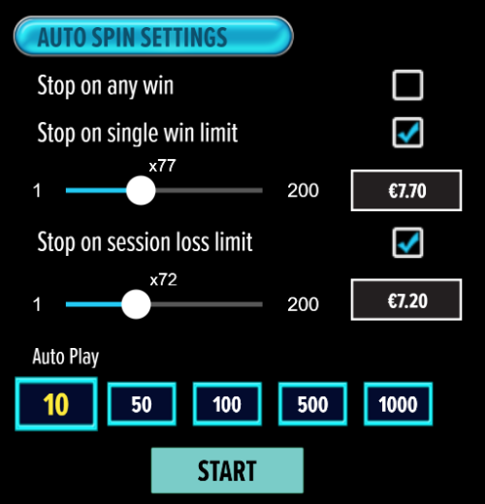

- All games are tested to level 3 standards in accordance with the UKGC Testing Strategy for Compliance with the Remote Gambling and Software Technical Standards.
- If the game is interrupted due to connection loss during Free Spins or Bonus Rounds, the game will resume the remaining Free Spins or the pending Bonus Round upon re-opening.
Auto Spin Game Rules:
- Auto Spin is similar to a regular spin; you can choose Auto Spin for a selected number of spins.
- As soon as Auto Spin begins, the Auto Spin button is replaced by a counter displaying the remaining Auto-bet rounds. The Auto Spin button changes to the Stop Auto Spin icon.
- Auto Spin automatically plays the game for the selected number of rounds.
- Auto Spin can be stopped at any time by clicking the Auto Spin (Auto Stop) button.
- Auto Spin settings will return to default when you trigger any Feature round (Free Spins/Bonus Round).
- If you are disconnected while playing, all Auto-play settings will return to default when you reload the game.
Additional Information:
- Guidance on RTP/Paylines/Bonus Feature/Wild/Free Spins is covered under the Paytable section of respective games. You can access this by clicking the Paytable button.
- Any stakes placed are non-refundable, unless a system malfunction occurs, in which case, all stakes placed on the game being played at the time of the malfunction will be refunded. We have no obligation to repay players who abuse these occurrences, and therefore, an alternative may be deemed suitable depending on the individual circumstances.
- The in-game paytable payouts are calculated as coin value * paytable factor when bet lines are kept constant.
- If a query arises as a result of a gaming session, where there is a mismatch between your records and the data recorded by our servers, the latter will be considered correct.
- In the event of any disagreement between yourself and this website, the management's decision will be considered final.
- If the game is interrupted due to connection loss, Balance and Win information can be viewed using Game Logs.
- In the event of malfunction of gaming hardware/software, all affected game bets and payouts are rendered void and all affected bets are refunded.

