Viking's Chess - The Conqueror's Game Rules
By playing our games, you agree that you do not find them offensive, unfair or indecent.
How to Play Slots:
- Choose the amount you would like to bet with. Control the bet amount by clicking the arrows next to the Coin Value or choose Max Bet (Max Coin Value).
- Your winnings are automatically added to your account balance. You can see your Total Win displayed in the WIN section of the screen after each spin.
Game Rules:
- 3 or more matching symbols connected either vertically or horizontally is a winning combination.
- Any combination of 3 or more King or Queen symbols wins.
- Payouts are made according to the paytable.
- Wins are multiplied by Coin Value and each game costs a minimum of 20 fixed coins.
- Only the highest win in the winning combination is paid.
- Malfunction voids all pays and plays.
- For this game, the long-term expected payback is 95.42%.

Gravalanche Feature:
- A winning combination triggers Gravalanche.
- The win amount is paid and all winning symbols explode and disappear. Symbols that are left drop down to replace exploded symbols, and new symbols drop down to fill the reel.
- If a WILD lands on any one of the 4 corner Hotspots (Home Hotspots) or in the centre of the grid (King’s Hotspot), it does not explode and stays in the Hotspot for the duration of the Gravalanche round.
- This sequence continues until there are no more winning combinations.

Home Hotspots:
- These Hotspots are located on the 4 corners of the grid.
- When a WILD symbol lands on Home Hotspots, X2 multiplier is applied to the winning combination triggered by the WILD.
- If there is a 5-line win with 2 Home Hotspot WILDS, the multipliers multiply with each other and a X4 multiplier is applied to the win.
- The multiplier is applicable only to the winning combinations that formed with the Home Hotspot WILDS.
- Wins without WILD symbols in the Home Hotspots are paid as per the paytable.

King’s Hotspot:
- This Hotspot is located in the centre of the grid.
- When a WILD symbol lands on King’s Hotspot, it transforms adjacent symbols in to WILDS. A win amount is paid for all winning combinations.
- The WILD on the King’s Hotspot remains in the same position until the end of the Gravalanche round but does not generate additional adjacent WILDS during the remainder of the Gravalanche round.
Free Spins:
- 3 or more WILDS on any Hotspot (Home or King) triggers Free Spins. Free Spins start when all features from Hotspots are played and no more Gravalanches are possible.
  - 3 WILDS in Hotspots = 10 Free Spins
  - 4 WILDS in Hotspots = 15 Free Spins
  - 5 WILDS in Hotspots = 20 Free Spins
- As in the base game, if during Free Spins a WILD lands on a Home Hotspot, it stays there for the duration of the Gravalanche round. If a WILD lands on any Home Hotspot, the multiplier increases by 1 and does not reset for the whole duration of Free Spins. Multiple WILDS can land on multiple Home Hotspots.
- The King’s Hotspot behaves the same as in the base game.
- If 3 or more WILDS land on any Hotspot during Free Spins, additional Free Spins are awarded as shown below.
  - 3 WILDS in Hotspots = 3 Free Spins
  - 4 WILDS in Hotspots = 4 Free Spins
  - 5 WILDS in Hotspots = 5 Free Spins
Wild Symbol:
Wild symbol substitutes for all symbols.
Game Controls:
This section lists the different buttons found in the game and describes their functions.

Buttons | Function
 | Click to open menu
 | Click to open the PAYTABLE
 | Click to open the GAME SETTINGS
 | Click to open the GAME RULES
 | Click to switch full screen/exit full screen
 | Click to switch Sound on/off
 | Click to Spin
 | Click to Max bet on a round
 | Click to open Auto-bet
 | Click the arrows, pointing towards left or right, to scroll through the paytable pages
 | Click the X button to return to the game

You can place restrictions on gameplay by following any of these options:
- Stop on any win: Auto-bet function is stopped when you get any winning combination.
- Stop on single win limit: Based on the limit value selected, the Auto-bet function is stopped when your total win in a single game reaches the selected value.
- Stop on session loss limit: Based on the limit value selected, the Auto-bet function is stopped when your total loss in the session reaches the selected value, which is derived by bets minus wins.
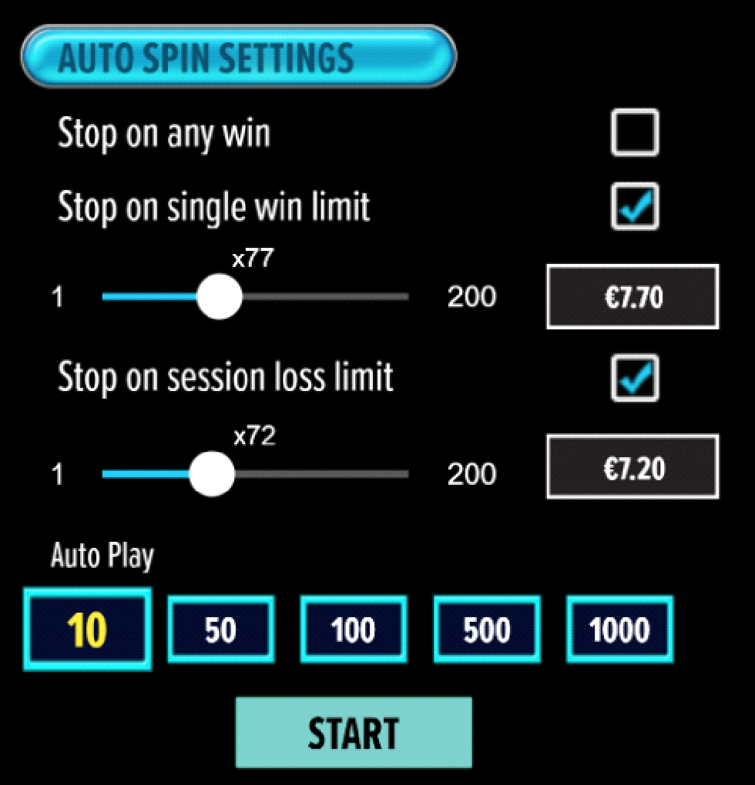
- All games are tested to level 3 standards in accordance with the UKGC Testing Strategy for Compliance with the Remote Gambling and Software Technical Standards.
- If the game is interrupted due to connection loss during Free Spins or Bonus Rounds, the game will resume the remaining Free Spins or the pending Bonus Round upon re-opening.
Auto Spin Game Rules:
- Auto Spin is similar to a regular spin; you can choose Auto Spin for a selected number of spins.
- As soon as Auto Spin begins, the Auto Spin button is replaced by a counter displaying the remaining Auto-bet rounds. The Auto Spin button changes to the Stop Auto Spin icon.
- Auto Spin automatically plays the game for the selected number of rounds.
- Auto Spin can be stopped at any time by clicking the Auto Spin (Auto Stop) button.
- Auto Spin settings will return to default when you trigger any Feature round (Free Spins/Bonus Round).
- If you are disconnected while playing, all Auto-play settings will return to default when you reload the game.
Additional Information:
- Guidance on RTP/Bonus Feature/Wild/Free Spins is covered under Paytable section of respective games. You can access this by clicking the “Paytable” button.
- Any stakes placed are non-refundable, unless a system malfunction occurs, in which case, all stakes placed on the game being played at the time of the malfunction will be refunded. We have no obligation to repay players who abuse these occurrences, and therefore, an alternative action may be deemed suitable depending on the individual circumstances.
- The in-game paytable shows symbol payouts as the multipliers on the total bet amount, which is calculated as 'total bet = (coin value * number of fixed coins)'. Hence the actual payouts will be coin value * paytable factor when bet lines are kept constant.
- If a query arises as a result of a gaming session, where there is a mismatch between your records and the data recorded by our servers, the latter will be considered correct.
- In the event of any disagreement between yourself and this website, the management's decision will be considered final.
- If the game is interrupted due to connection loss, Balance and Win information can be viewed using Game Logs.
- In the event of malfunction of gaming hardware/software, all affected game bets and payouts are rendered void and all affected bets are refunded.

