Shelby Online Video Slot Game Rules
By playing our games, you agree that you do not find them offensive, unfair or indecent.
How to Play Slots:
- Choose the amount you would like to bet with. Control the bet amount by clicking the arrows next to the Coin Value or choose BOOST BET for additional benefits in the game (Extra Coin Value).
- Your winnings are automatically added to your account balance. You can see your Total Win displayed in the WIN section of the screen after each spin.
Game Rules:
- The game is played with 30 fixed paylines and each spin costs a minimum of 10 fixed coins in BET mode and 15 fixed coins in BOOST BET mode.
- Payouts are made according to the paytable.
- Payline prizes are multiplied by the coin value.
- All symbols pay from left to right in consecutive order, excluding the Carroll Shelby symbol.
- Only the highest win is paid per selected line.
- Malfunction voids all pays and plays.
- For this game, the long-term expected payback is 95.77% on BET mode.
- For this game, the long-term expected payback is 96.33% on BOOST BET.

Shelby Collection Feature:
- If Cobra symbol lands on reel 5 in the base game or Racing Free Spins, additional win can be awarded.
- This win is calculated for each Car symbol present on the screen as per the Shelby Collection paytable value.

Bonus Feature:

Three Carroll Shelby symbols appearing in the main game trigger Racing Free Spins or Auction Bonus Game.
Racing Free Spins:
- If the 3rd Carroll Shelby symbol is a Free Spins symbol, 15 Racing Free Spins are awarded.
- Progressive Multiplier: When Free Spins are awarded, one of the Car symbols is selected as a Racing symbol for the duration of Free Spins.
- In Free Spins progressive multiplier is applied to each win, based on the accumulated number of Racing symbols appearing on the reels as per the tables below:

ACCUMULATED NUMBER OF
RACING SYMBOLS
 | BET MODE MULTIPLIER | BOOST BET MODE MULTIPLIER
0-4 | x1 | x2
5-9 | x2 | x3
10-14 | x3 | x4
15-19 | x4 | x5
20-21 | x5 | x7
22-23 | x7 | x10
24-25 | x10 | x20
26-27 | x20 | x30
28-29 | X30 | x50
30+ | x50 | x100

- Shelby Collection feature is also available in Racing Free Spins and functions the same way as in base game.
Auction Bonus Game:
- If the 3rd Carroll Shelby symbol is a Bonus symbol, Auction Bonus Game is awarded.
- Click on the individual paddles to reveal up to 12 prizes.
- Each click awards a coin win.
- Bonus game is complete when SOLD is picked.
- In BET mode the player can be awarded maximum 2,000 coins which is sum of all possible coin wins.
- In BOOST BET mode the player can be awarded maximum 4,000 coins which is sum of all possible coin wins.
Wild Symbol:
Wild symbol substitutes for all symbols, excluding Carroll Shelby and Shelby Collection symbols.
Game Controls:
This section lists the different buttons found in the game and describes their functions.

Buttons | Function
 | Click to open menu
 | Click to open the PAYTABLE
 | Click to open the GAME SETTINGS
 | Click to open the GAME RULES
 | Click to switch full screen/exit full screen
 | Click to switch sound on/off
 | Click to spin
 | Click to place BOOST BET on a round
 | Click to place BET on a round
 | Click to open Auto-bet
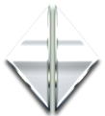 | Click the arrows, pointing towards left or right, to scroll through the paytable pages
 | Click the X button to return to the game

You can place restrictions on gameplay by following any of these options:
- Stop on any win: Auto-bet function is stopped when you get any winning combination.
- Stop on single win limit: Based on the limit value selected, the Auto-bet function is stopped when your total win in a single game reaches the selected value.
- Stop on session loss limit: Based on the limit value selected, the Auto-bet function is stopped when your total loss in the session reaches the selected value, which is derived by bets minus wins.
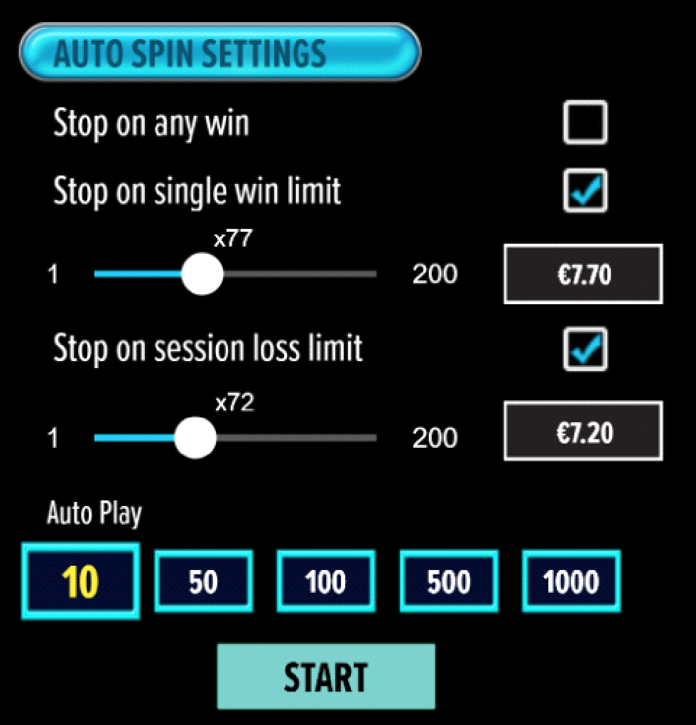
- All games are tested to level 3 standards in accordance with the UKGC Testing Strategy for Compliance with the Remote Gambling and Software Technical Standards.
- If the game is interrupted due to connection loss during Free Spins or Bonus Rounds, the game will resume the remaining Free Spins or the pending Bonus Round upon re-opening.
Auto Spin Game Rules:
- Auto Spin is similar to a regular spin; you can choose Auto Spin for a selected number of spins.
- As soon as Auto Spin begins, the Auto Spin button is replaced by a counter displaying the remaining Auto-bet rounds. The Auto Spin button changes to the Stop Auto Spin icon.
- Auto Spin automatically plays the game for the selected number of rounds.
- Auto Spin can be stopped at any time by clicking the Auto Spin (Auto Stop) button.
- Auto Spin settings will return to default when you trigger any Feature round (Free Spins/Bonus Round).
- If you are disconnected while playing, all Auto-play settings will return to default when you reload the game.
Additional Information:
- Guidance on RTP/Paylines/Bonus Feature/Wild/Free Spins is covered under the Paytable section of respective games. You can access this by clicking the Paytable button.
- Any stakes placed are non-refundable, unless a system malfunction occurs, in which case, all stakes placed on the game being played at the time of the malfunction will be refunded. We have no obligation to repay players who abuse these occurrences, and therefore, an alternative action may be deemed suitable depending on the individual circumstances.
- The in-game paytable shows symbol payouts as the multipliers on the total bet amount, which is calculated as 'total bet = (coin value * number of fixed coins)'. Hence the actual payouts will be coin value * paytable factor when bet lines are kept constant.
- If a query arises as a result of a gaming session, where there is a mismatch between your records and the data recorded by our servers, the latter will be considered correct.
- In the event of any disagreement between yourself and this website, the management's decision will be considered final.
- If the game is interrupted due to connection loss, Balance and Win information can be viewed using Game Logs.
- In the event of malfunction of gaming hardware/software, all affected game bets and payouts are rendered void and all affected bets are refunded.

