Treasures of Egypt Game Rules
By playing our games, you agree that you do not find them offensive, unfair or indecent.

How to Play Slots:
- Choose the amount you would like to bet with. Control the bet amount by clicking the arrows next to the Coin Value or choose Max Bet (Max Coin Value).
- Your winnings are automatically added to your account balance. You can see your Total Win displayed in the WIN section of the screen after each spin.

Game Rules:
- The game is played with 10 fixed paylines and each game costs a minimum of 10 fixed coins.
- Payouts are made according to the paytable.
- Payline prizes are multiplied by coin value.
- All symbols pay from left to right in consecutive order only, excluding the Bonus symbol.
- Highest win only paid per selected line.
- Malfunction voids all pays and plays.
- For this game, the long-term expected payback is 95.50%.

Bonus Symbol:
- Landing 3 or more Bonus symbols starts Free Spins.
- 3 Bonus symbols = 10 Free Spins.
- 4 Bonus symbols = 15 Free Spins.
- 5 Bonus symbols = 20 Free Spins.

Wild Symbol:
- Wild symbols substitute for all symbols, excluding the Bonus symbol.
- In the main game, Wild symbols land only on reels 1, 2 and 3.

Free Spins:
- Free Spins have a progress bar starting from 0 going up to 20. Each Bonus symbol landing on the reels moves up the progress bar.
- 4 progress points unlock additional Free Spins features that are present for the rest of the round.
Level 1: Sticky Wild Reel + 1 Free Spin.
Level 2: Multiplier x2 + 1 Free Spin.
Level 3: Second Sticky Wild Reel + 2 Free Spins.
Level 4: Win both ways + 2 Free Spins.
Level 5: Third Sticky Wild Reel + 2 Free Spins.
- If a Bonus symbol lands on a Sticky Wild Reel, the Bonus symbol is added to the progress bar, then the Wild Reel is activated.
- From level 4 in Free Spins, wins are paid from left to right and right to left. 5x wins are only paid once.

Game Controls:
This section lists the different buttons found in the game and describes their functions.

Buttons | Function
 | Click to open menu
 | Click to open the PAYTABLE
 | Click to open the GAME SETTINGS
 | Click to open the GAME RULES
 | Click to switch full screen/exit full screen
 | Click to switch Sound on/off
 | Click to Spin
 | Click to Max bet on a round
 | Click to open Auto-bet
 | Click the Arrows, pointing towards left or right, to scroll through the paytable pages
 | Click the X button to return to the game

You can place restrictions on gameplay by following any of these options:
- Stop on any win: Auto-bet function is stopped when you get any winning combination.
- Stop on single win limit: Based on the limit value selected, the Auto-bet function is stopped when your total win in a single game reaches the selected value.
- Stop on session loss limit: Based on the limit value selected, the Auto-bet function is stopped when your total loss in the session reaches the selected value, which is derived by bet minus wins.

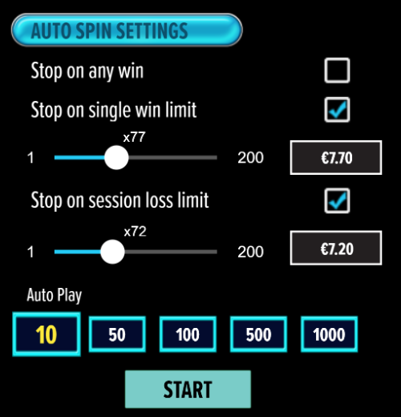

- All games are tested to level 3 standards in accordance with the UKGC Testing Strategy for Compliance with the Remote Gambling and Software Technical Standards.
- If the game is interrupted due to connection loss during Free Spins or Bonus Rounds, the game will resume the remaining Free Spins or the pending Bonus Round upon re-opening.

Auto Spin Game Rules:
- Auto Spin is similar to regular spins; you can choose Auto Spin for a selected number of spins.
- As soon as Auto Spin begins, the Auto Spin button is replaced by a counter displaying the remaining Auto-bet rounds. The Auto Spin button changes to the Stop Auto Spin icon.
- Auto Spin automatically plays the game for the selected number of rounds.
- Auto Spin can be stopped at any time by clicking the Auto Spin (Auto Stop) button.
- Auto Spin settings will return to default when you get any feature round (Free Spins/Bonus Round).
- If you are disconnected while playing, all Auto-play settings will return to default when you reload the game.

Additional Information:
- Guidance on RTP/Paylines/Bonus Feature/Wild/ Free Spins is covered under the Paytable section of respective games. You can access this by clicking the Paytable button.
- Any stakes that you place are non-refundable, unless a system malfunction occurs, in which case, all stakes placed on the particular game being played at the time of the malfunction will be refunded. We have no obligation to repay players who abuse these occurrences, and therefore, an alternative may be deemed suitable depending on the individual circumstances.
- The in-game paytable shows symbol payouts as the multipliers on the total bet amount, which is calculated as 'total bet = (coin value * number of fixed coins)'. Hence the actual payouts will be coin value * paytable factor when bet lines are kept constant.
- If a query arises as a result of a gaming session, where there is a mismatch between your records and the data recorded by our servers, the latter will be considered correct.
- In the event of any disagreement between yourself and this website, the management's decision will be considered final.
- If the game is interrupted due to connection loss Balance and Win information can be viewed using Game Logs.
- In the event of malfunction of gaming hardware/software, all affected game bets and payouts are rendered void and all affected bets refunded.

