Candy Bears Sweet Wins Game Rules
By playing our games, you agree that you do not find them offensive, unfair or indecent.

How to Play Slots:
- Choose the amount you would like to bet with. Control the bet amount by clicking the arrows next to the Coin Value or choose Max Bet (Max Coin Value).
- Your winnings are automatically added to your account balance. You can see your Total Win displayed in the WIN section of the screen after each spin.

Game Rules:
- 9 or more matching symbols connected in a cluster, either vertically or horizontally, is a winning combination.
- Count the number of identical symbols that form a winning combination.
- Payouts are made according to the paytable.
- Wins are multiplied by Coin Value and each game costs a minimum of 10 fixed coins.
- Only the highest win in the winning combination is paid.
- Malfunction voids all pays and plays.
- For this game, the long-term expected pay back is 95.54%.

Free Spins:
- Free Spins (Scatter) symbols can appear on all reels.
- 3 or more Free Spins symbols appearing anywhere on the reels trigger Free Spins.
- 1 or more Free Spins symbols on a reel are counted as only 1 per reel.
- During Free Spins 3, 4, 5 or 6 Free Spins symbols award 1, 2, 3 or 4 additional Free Spins respectively.
- From 3rd Free Spin onwards Purple Candy symbol will not be awarded.
- From 5th Free Spin onwards Orange Candy symbol will not be awarded.
- From 7th Free Spin onwards Green Candy symbol will not be awarded.
- From 9th Free Spin onwards Blue Candy symbol will not be awarded.

Wild Symbol:
- Wild symbols substitute for all adjacent symbols, excluding the Free Spins symbols in a cluster win.
- Wild symbols can be a part of one or more simultaneous win combinations.

Wild Spawn Feature:
- If there are less than 3 Free Spins symbols on the reels, there is a chance to trigger the Wild Spawn feature.
- This feature adds a random number of Wilds to the reels.
- Reels with Free Spins symbols are excluded.
- This feature cannot be triggered during Sticky Win Re-Spins.

Sticky Win Re-Spin Feature:
- A cluster win randomly activates the Sticky Win Re-Spins feature.
- 9 or more of the same symbols, and/or Wilds, appearing in a cluster, adjacent horizontally or vertically, award a win.
- The initial win is not paid instantly but accumulated to the Sticky Win Re-Spins round.
- During a Sticky Win Re-Spin, the winning symbols are held in place on the reels while all other symbols re-spin. If the winning cluster size increases, the symbols increasing the size of the cluster also stick and the remaining non-winning symbols re-spin again. This continues until the cluster stops increasing with matching symbols or until a cluster completely fills the screen. The final cluster win is awarded.
- A Re-Spin cannot be activated if the initial spin includes two separate winning clusters.
- The Sticky Win Re-Spin feature cannot be activated during Free Spins if 3 or more Free Spins symbols are on the reels when the Wild Spawn feature was activated.

Game Controls:
This section lists the different buttons found in the game and describes their functions.

Buttons | Function
 | Click to open menu
 | Click to open the PAYTABLE
 | Click to open the GAME SETTINGS
 | Click to open the GAME RULES
 | Click to switch full screen/exit full screen
 | Click to switch Sound on/off
 | Click to Spin
 | Click to Max bet on a round
 | Click to open Auto-bet
 | Click the Arrows, pointing towards left or right, to scroll through the paytable pages
 | Click the X button to return to the game

You can place restrictions on gameplay by following any of these options:
- Stop on any win: Auto-bet function is stopped when you get any winning combination.
- Stop on single win limit: Based on the limit value selected, the Auto-bet function is stopped when your total win in a single game reaches the selected value.
- Stop on session loss limit: Based on the limit value selected, the Auto-bet function is stopped when your total loss in the session reaches the selected value, which is derived by bet minus wins.

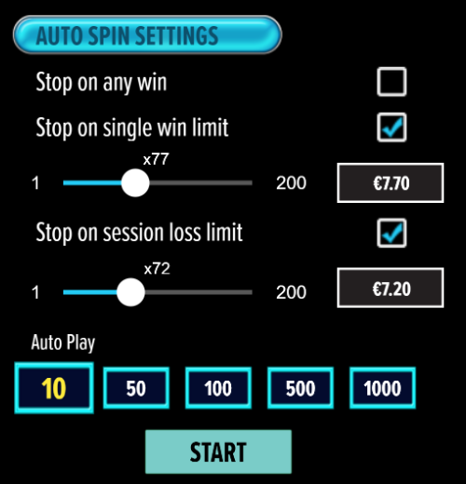

- All games are tested to level 3 standards in accordance with the UKGC Testing Strategy for Compliance with the Remote Gambling and Software Technical Standards.
- If the game is interrupted due to connection loss during Free Spins or Bonus Rounds, the game will resume the remaining Free Spins or the pending Bonus Round upon re-opening.

Auto Spin Game Rules:
- Auto Spin is similar to regular spins; you can choose Auto Spin for a selected number of spins.
- As soon as Auto Spin begins, the Auto Spin button is replaced by a counter displaying the remaining Auto-bet rounds. The Auto Spin button changes to the Stop Auto Spin icon.
- Auto Spin automatically plays the game for the selected number of rounds.
- Auto Spin can be stopped at any time by clicking the Auto Spin (Auto Stop) button.
- Auto Spin settings will return to default when you trigger any feature round (Free spins/Bonus Round).
- Auto Spin will continue after completion of Re-Spins.
- If you are disconnected while playing, all Auto-play settings will return to default when you reload the game.

Additional Information:
- Guidance on RTP/paylines/Bonus feature/Wild/Free Spins is covered under the Paytable section of respective games. You can access this by clicking the Paytable button.
- Any stakes that you place are non-refundable, unless a system malfunction occurs, in which case, all stakes placed on the particular game being played at the time of the malfunction will be refunded. We have no obligation to repay players who abuse these occurrences, and therefore, an alternative may be deemed suitable depending on the individual circumstances.
- The in-game paytable shows symbol payouts as the multipliers on the total bet amount, which is calculated as 'total bet = (coin value * number of fixed coins)'. Hence the actual payouts will be coin value * paytable factor when bet lines are kept constant.
- If a query arises as a result of a gaming session, where there is a mismatch between your records and the data recorded by our servers, the latter will be considered correct.
- In the event of any disagreement between yourself and this website, the management's decision will be considered final.
- If game is interrupted due to connection loss Balance and Win information can be viewed using Game Logs.
- In the event of malfunction of gaming hardware/software, all affected game bets and payouts are rendered void and all affected bets refunded.

