Age of Davinci Game Rules
By playing our games, you agree that you do not find them offensive, unfair or indecent.

How to Play Slots:
- Choose the amount you would like to bet with. Control the bet amount by clicking the arrows next to the Coin Value or choose Max Bet (Max Coin Value).
- Your winnings are automatically added to your account balance. You can see your Total Win displayed in the WIN section of the screen after each spin.

Game Rules:
- The game is played with 20 paylines and each game costs a minimum of 20 fixed coins.
- Payouts are made according to the paytable.
- Payline prizes are multiplied by coin value.
- All symbols pay from left to right in consecutive order, excluding the Bonus symbol.
- Highest win only paid per selected line.
- Malfunction voids all pays and plays.
- For this game, the long-term expected payback is 96.51%.

Main Game Features:
If less than 3 Bonus symbols appear on the screen in the main game, there is a chance to trigger a main game feature.
Possible features:
- Random Wild feature
- Unity feature
- Random Multiplier feature
- Magnum Opus feature

Random Wild Feature:
- This feature adds a random number of Wilds, starting from the leftmost reel, with a maximum of one Wild added to each reel in a random position.
- This feature almost guarantees a win and a decent chance for a Big Win combination.

Unity Feature:
During this feature, all low-value symbols (A, K, Q, J) act as Wilds for each other. This means they substitute for other low-value symbols in order to produce a winning combination.

Random Multiplier Feature:
- Following a spin, the Random Multiplier feature may be activated. This triggers an additional Re-Spin while the reels are spinning. A Random Multiplier between x4 and x15 is awarded. Each Multiplier has the same probability of being chosen.
- Random Multiplier only affects the Re-Spin win, not the win in the main game. During the Random Multiplier Free Spins, the Multiplier changes on every spin. No Re-Spins are granted in Free Spins.

Magnum Opus Feature:
- The killer feature of the game sees a 3x3 block of the same symbol appearing on the reels.
- The block of symbols is placed, and the winnings are paid to the player.

Bonus Symbol:
- 3 Bonus symbols appearing in the main game triggers the Bonus Pick mode.
- During the Bonus Pick, a wheel appears and the player chooses which Free Spins to play. The Free Spins are played with the chosen feature appearing in every spin.
- Additional Free Spins can be won in every during Free Spins by landing 3 Bonus symbols on the reels.
Possible Modes:
- 7 Free spins with Random Wild feature.
- 5 Free spins with Unity feature.
- 5 Free spins with Random Multiplier feature.
- 5 Free spins with Magnum Opus feature.
- Get 20 total bets and return to the main game.
- During Free Spins, the Magnum Opus feature only appears if there are no Bonus symbols on screen.
- 3 Bonus symbols appearing on the screen during Free Spins awards the same amount of additional Free Spins as in the Bonus Pick mode.

Wild Symbol:
Wild symbols substitute for all symbols, excluding the Bonus symbol.

Game Controls:
This section lists the different buttons found in the game and describes their functions.

Buttons | Function
 | Click to open menu
 | Click to open the PAYTABLE
 | Click to open the GAME SETTINGS
 | Click to open the GAME RULES
 | Click to switch full screen/exit full screen
 | Click to switch Sound on/off
 | Click to Spin
 | Click to Max bet on a round
 | Click to open Auto-bet
 | Click the Arrows, pointing towards left or right, to scroll through the paytable pages
 | Click the X button to return to the game

You can place restrictions on game play by following any of these options
- Stop on any win: Auto-bet function is stopped when you get any winning combination.
- Stop on single win limit: Based on the limit value selected, the Auto-bet function is stopped when your total win in a single game reaches the selected value.
- Stop on session loss limit: Based on the limit value selected, the Auto-bet function is stopped when your total loss in the session reaches the selected value, which is derived by bet minus wins.

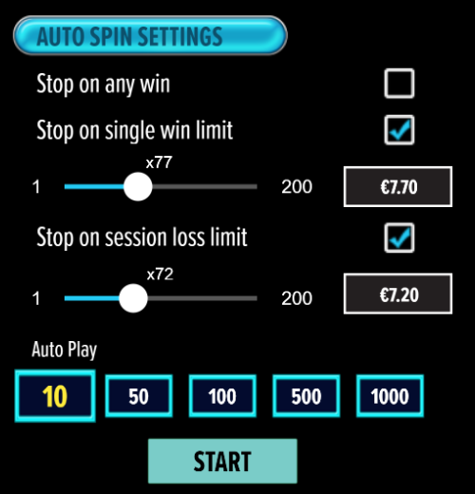

- All games are tested to level 3 standards in accordance with the UKGC Testing Strategy for Compliance with the Remote Gambling and Software Technical Standards.
- If the game is interrupted due to connection loss during Free Spins or Bonus Rounds, the game will resume the remaining Free Spins or the pending Bonus Round upon re-opening.

Auto Spin Game Rules:
- Auto Spin is similar to regular spins; you can choose Auto Spin for a selected number of spins.
- As soon as Auto Spin begins, the Auto Spin button is replaced by a counter displaying the remaining Auto-bet rounds. The Auto Spin button changes to the Stop Auto Spin icon.
- Auto Spin automatically plays the game for the selected number of rounds.
- Auto Spin can be stopped at any time by clicking the Auto Spin (Auto Stop) button.
- Auto Spin settings will return to default when you get any feature round (Free Spins/Bonus Round).
- Auto Spin will be continued after completion of Re-Spins.
- If you are disconnected while playing, all Auto-play settings will return to default when you reload the game.

Additional Information:
- Guidance on RTP/paylines/Bonus feature/Wild/Free spins is covered under Paytable section of respective games. You can access this by clicking the Paytable button.
- Any stakes that you place are non-refundable, unless a system malfunction occurs, in which case, all stakes placed on the particular game being played at the time of the malfunction will be refunded. We have no obligation to repay players who abuse these occurrences, and therefore, an alternative may be deemed suitable depending on the individual circumstances.
- The in-game paytable shows symbol payouts as the multipliers on the total bet amount which is calculated as 'total bet = (coin value * number of fixed coins)'. Hence the actual payouts will be coin value * paytable factor when bet lines are kept constant.
- If a query arises as a result of a gaming session, where there is a mismatch between your records and the data recorded by our servers, the latter will be considered correct.
- In the event of any disagreement between yourself and this website, the management's decision will be considered final.
- If the game is interrupted due to connection loss Balance and Win information can be viewed using Game Logs.
- In the event of malfunction of gaming hardware/software, all affected game bets and payouts are rendered void and all affected bets refunded.

